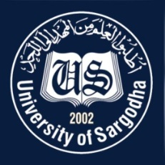 | Faculty Positions on Visiting Basis
Department of Biotechnology
University of Sargodha
Applications for the following positions are invited from Pakistani nationals for Spring semester 2021.
Teaching Faculty

Sr.# | Positions | No. of Posts | Nature of Post | Eligibility Criteria
1. | Visiting Assistant Professor / Lecturers | 03 | Visiting Faculty  (Open merit, for Spring semester 2021). | Qualification:-  - Ph.D in relevant field for Assistant Professor  - MS / M.Phil in relevant field for Lecturer
NOTE |  |  | General Information
- As per university policy, the institute/department reserves the right not to consider any application or fill any post without giving any reason.
- Candidates are required to submit complete C.V and attested copies of testimonials along with
duly filled application form in the department office.
- Prescribed application form may be downloaded from university website
(https://www .uos.edu .pk/adminForms)
- Applications complete in all respects should reach the department on or before 15-2-2021.
- Interview of the short-listed candidates will be conducted on 18-2-2021 (at11:00 am) in the office of Incharge, Department of Biotechnology, Sargodha University
- Only short listed candidates will be called for interview.
- The applicants having provisional transcript will not be eligible for the visiting faculty
- Applications received after due date will not be entertained.
- Candidates with relevant experience will be preferred.
- Seats can be increased or decreased according to the requirement of subjects.
- Applications address to Incharge, Department of Biotechnology, University of Sargodha.
- Online applications will not be accepted.

Dr. Muhammad Irfan
Incharge
Department of Biotechnology
University of Sargodha

